OPUS Terminal Solution

Dashboard
System

Revision History
The revision history of the instruction manual is as following.

Date | Product Version | Manual Version | Description
2016.10. |  | 1.0 | Published

Content

1. View Item List 5
2. Vessel / Berth 7
2.1 Actual Berthing / Berth Occupied 7
2.2 Vessel Work Status 8
2.3 Total Break Time 11
2.4 Pool Status 12
2.5 T/S Work Plan Status 12
3. Yard 13
3.1 Yard Block Density 13
3.2 Yard Ratio 14
3.3 ARMGC/ECH/ITV Productivity 15
3.4 Workload by Block 15
3.5 Work Balance 16
3.6 YC Productivity 16
3.7 Yard Stacking Status 17
3.8 Block Work Status 18
3.9 Plug In/Out List 20
3.10 Block Traffic List 21
4. Equipment 22
4.1 QC Summary 22
4.2 ARMGC Summary 23
4.3 ARMGC Work Status 23
4.4 ECH Summary 24
4.5 ECH Work Status 25
4.6 ITV Summary 26
4.7 ITV Work Status 26
4.8 ITV Fuel List 27
4.9 ITV Monitor 28
5. Gate 29
5.1 Gate Summary 29
5.2 Gate Capacity Status 30
6. Utility - System KPI Setup 31
6.1 System KPI Setup 31
7. Utility - User Management 33
7.1 User 33
7.2 Access Role 34
7.3 Access Action Control 35

View Item List

Menu | Description
Vessel / Berth | - Actual Berthing / Berth Occupied : Display about the actual berthing vessel / voyage quantity and display the berth occupied utilization.  - Vessel Work Status : Display the Vessel Work Status by Vessel Type(ML/DF/CC).  Display the Total/Complete/Remain/GMPH/BMPH/Twin/Single/Tandem/Dual fields.  - Detail VVD Information : Display the current VVD work status detail information.  List the VVD Schedule/work status/QC Productivity.  - Detail GC List : : Display the current QC work status information for specific VVD.  List the Work status(Total/Size/Single/Twin/Tandem/Productivity) by each QC.  - Total Break Time : Display the total QC break time for last two hours.  - QC Work Stop : Display the total QC Work Stop Code list for last two hours.  - Pool Status : Display the current Pool status(Assigned ITV/LogOn/Fetching/  Average ITV by QC).  - T/S Work Plan Status : Display the twin operation's plan and actual work status for last 1 hour.
Yard | - Yard Block Density :Display the Yard Stacking Staus(Stacking TEU / Ratio) of Automatic/Empty Block.  - Yard Ratio : Display the Yard Stacking Staus(Stacking capacity-TEU / Ratio) by 20'/40' Size.  - ARMGC/ECH/ITV Productivity : Display the yard machine productivity for latest 1 hour.  - Workload by Block : Display the current remain workload by each yard block.  - Work Balance : Display the Terminal In / Out(Discharge or Gate In / Load or Gate Out ) Quantity for latest 1 hour.  - YC Productivity : Display the yard machine productivity of job type for latest 1 hour.  - Yard Stacking Status : Display the yard stacking volume / ratio of class type(MT/IMP/EXP/TS) by yard block.  - Block Work Status : Display the reefer work status / block work status / block traffic status.  - Reefer Work Status : Display the average reefer processing work time/current reefer  stacking status(Stacking TEU/Ratio)/plug in-out quantity(Plug In/Out workload of overtime  by user setup waiting time).  - Block Work Status : Display the current workload quantity / ratio and average working time  for latest 1 hour by each yard block.  - Block Traffic : Display the current ITV/OTR volume of waiting time by overtime of user  setup waiting time by each yard block.  - Block Trafiic List : Display the ITV/OTR detail list(ITV / Job Type/ Wait time) of waiting time by overtime of user setup waiting time by each yard block.  - Plug In/Out List : Display the plug in/out container list(CNTR No/Job/Vessel Voyage/ISO /Operator/Status/Location/Wait time) of waiting time by overtime of user setup waiting time.
Equipment | - QC Summary  - On Status : Display the current working QC /total QC machine quantity.  - QC Plan Status : Display the all planned QC machine quantity during next 4 hours.  - QC Job Summary(Comp.) : Display the QC completed work ratio for Single/Twin/Tandem/  Double operation during 3 hours.  - MMBF : Display the average QC moves for breakdown by machine manufacture.  - QC Work Status : Display all QC work final status for current or 1 hour future option.  - ARMGC Summary  - On Status : Display the current working(log-in) ARMGC machine quantity.  - Service for QC : Display the average service QC machine quantity for each ARMGC.  - Productivity : Display the current ARMGC machine productivity for latest 1 hour.  - Gate Work : Display the gate workload and gate work level(%) for ARMGC block.  - ARMGC Work Status  - Productivity : Display the each ARMGC machine productivity for latest 1 hour.  - Work Ratio : Display the real working time ratio of each ARMGC machine for 1 hour.  - Line Graph : Display the hourly productivity for today and previous(1 week ago) date.  - ECH Summary  - On Status : Display the current working(log-in) ECH block machine quantity.  - Productivity : Display the current ECH block machine productivity for latest 1 hour.  - Gate Work : Display the gate workload and gate work level(%) for ECH block.  - ECH Work Status  - Productivity : Display the each ECH machine productivity for latest 1 hour.  - Work Ratio : Display the real working time ratio of each ECH machine for 1 hour.  - Delay Time : Display the total ECH break time for 1 hour.  - Operation Status : Display the total/remain/completed work volume(20'/40'/OOG) for 1 hour.  - Line Graph : Display the hourly productivity for today total work, gate work and  previous(1 week ago) date.  - ITV Summary  - On Status : Display the current working(log-in) ITV machine quantity.  - Service for QC : Display the average service QC machine quantity for each ITV.  - Productivity : Display the current ITV machine productivity for latest 1 hour.  - Laden/Unladen : Display the ITV machine on status(Laden/Unladen) quantity.  - Plan/Actual Distance : Display the average ITV distance for Plan/Actual condition  during 2 hours.  - ITV Work Status  - ITV Idle Time : Display the the ITV detail list(ITV / Wait time / Status) of idle time by overtime  of user setup idle time.  - ITV Distance : Display the total / laden / unladen ITV status distance.  - ITV Breal Time : Display the ITV quantity for break time requested and approved.  - ITV Fuel : Display the ITV status quantity for out of gas and on station.  - ITV Fuel List : Display the the ITV detail list(ITV No/Remain fuel) for out of gas and on station.  - ITV Monitor : Display the the current ITV detail list of similar program for ITV Monitoring  on TOS application.
Gate | - Gate main summary : Display the gate capacity simulation function.  - Gate detail view  - Line graph : Display the hourly average gate process volume for today and previous  (1 week ago) date.  - Gate process volume : Display the current hourly gate process volume by each lane id.
Utility | - System KPI Setup : Inquire and save the KPI system setup value.  - User management  - User : Search and save the user information.  - Access Role : Search and save the access group role code.  - Access Action Control : Search and save the program access control by  access group role code.

Vessel / Berth
In this view, you can see about the berth and vessel operation work status summary and detail information.

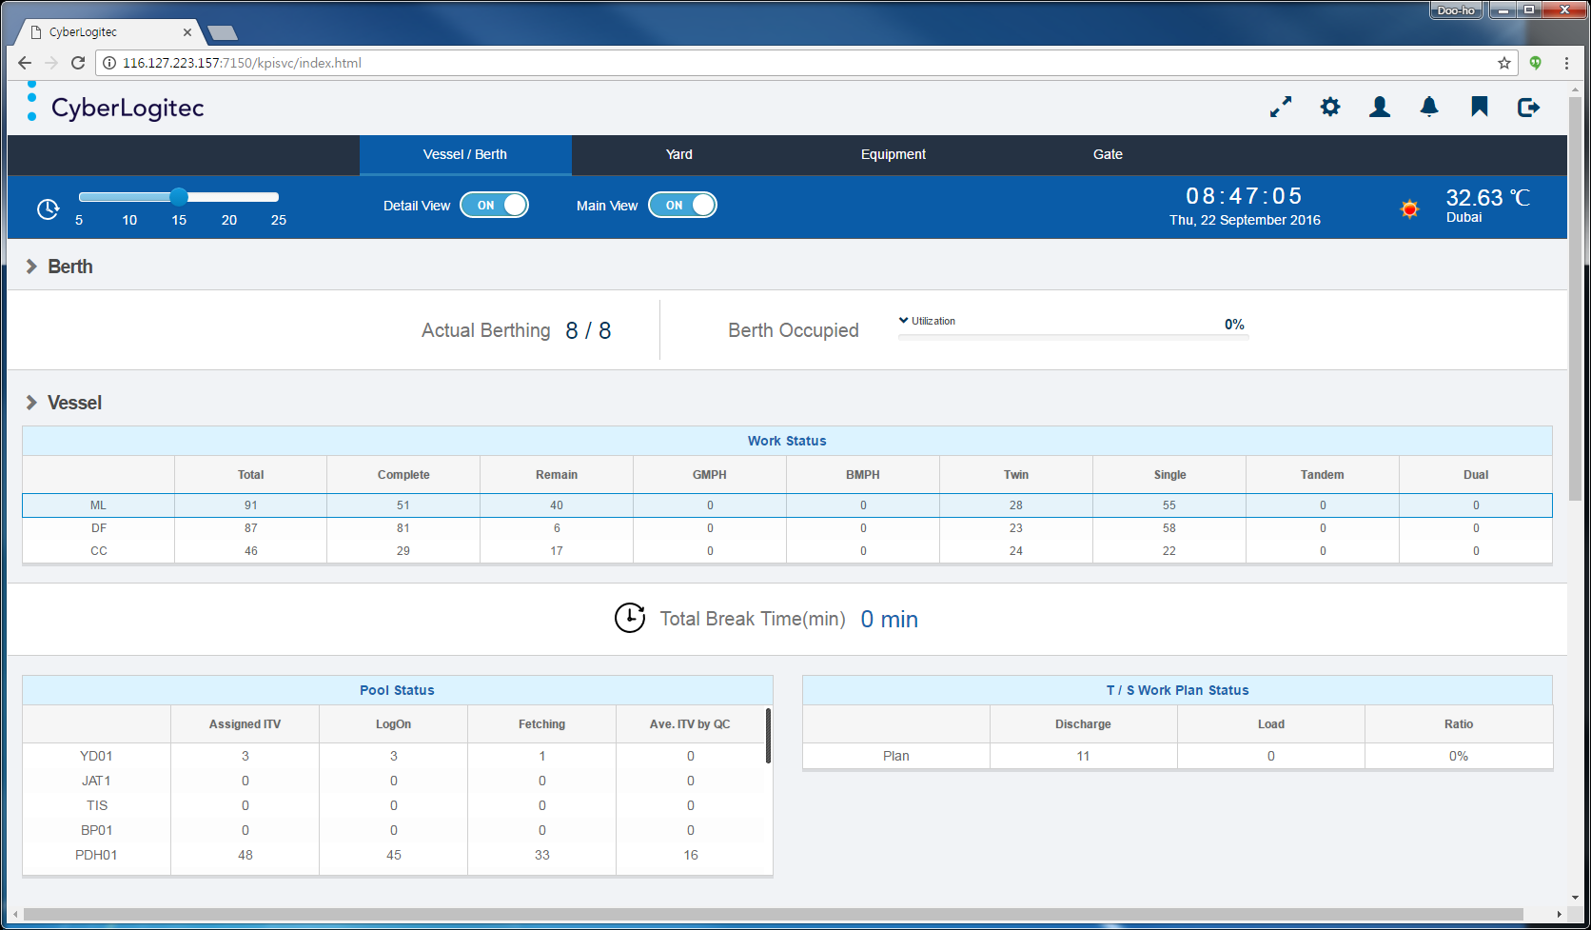
[Vessel/Berth Main Screen Layout]

Actual Berthing / Berth Occupied
In this view, you can see about the actual berthing vessel / voyage quantity and the berth occupied utilization.

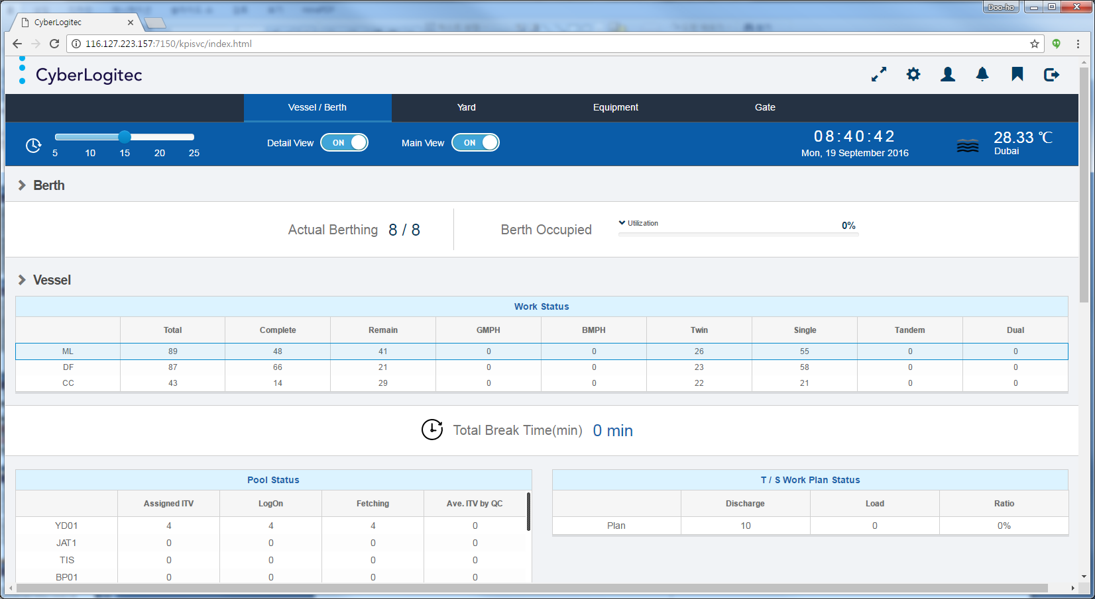
[Berth Screen Layout]

Classification | Description
Actual Berthing | - Actual berthing VVD Quantity : Display the current actual berthing vessel / voyage quantity  (Berth status : A - Arrived/ W - Working).  - Estiamted berthing VVD Quantity : Display the Actual berthing VVD quantity and  Estimated(current date) berthing vessel / voyage quantity
Berth Occupied | - Utilization : Display the current berth utilzation ratio.  (Source Interface data from PROMIS system)
[Berth Screen Layout Description]

Vessel Work Status
In this view, you can see about the current vessel work status by vessel type(ML/DF/ CC).
It displays the vessel work status(Total/Complete/Remain/GMPH/BMPH/Twin/Single/Tandem/Dual) by vessel type.

[Vessel Work Status Screen Layout]

Classification | Description
Vessel Type | - ML : Main Lines.  : This type is "M : Mother" vessel type on Vessel Voyage Detail of OPUS Terminal.  - DF : Direct Feeder.  : This type is "F : Feeder" vessel type on Vessel Voyage Detail of OPUS Terminal.  - CC : Common Carrier.  : This type is others vessel type(All types except " M : Mother " and " F : Feeder ")  on Vessel Voyage Detail of OPUS Terminal.
Fields | - Total : Display the total volume by same vessel type(Unit : Box).  - Complete : Display the compeletd volume by same vessel type(Unit : Box).  - Remain : Display the remain volume by same vessel type(Unit : Box).  - GMPH : Gross Moves Per Hour. Display the productivity for latest 1 hour by same vessel type.  - BMPH : Berth Moves Per Hour. Display the productivity for latest 1 hour by same vessel type.  - Twin : Display the twin operation volume by same vessel type(Unit : Box).  - Single : Display the single operation volume by same vessel type(Unit : Box).  - Tandem : Display the tandem operation volume by same vessel type(Unit : Box).  - Dual : Display the dual operation volume by same vessel type(Unit : Move).
[Vessel Work Status Screen Layout Description]

Detail VVD Information
In this view, you can see about the each vessel voyage work status detail information by same vessel type.
It displays the current vessel voyage schedule, work status and productivity .

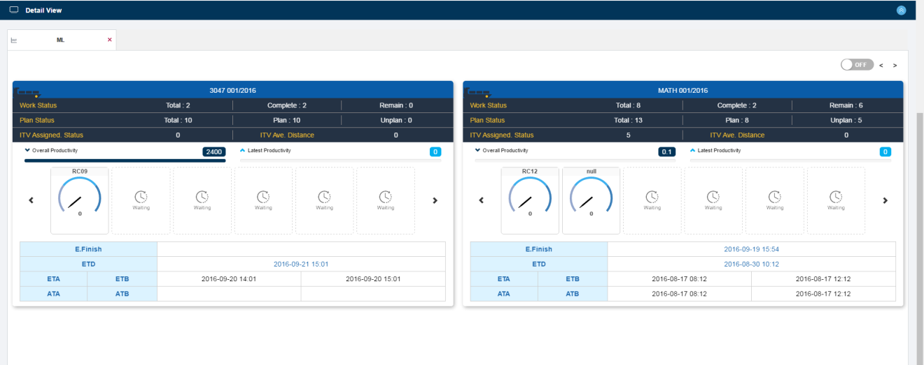
[Detail VVD Information Screen Layout]

Classification | Description
VVD | - VVD : Vessel Voyage Code(Vessel Code / Voyage Sequence)  - Berth Direction(Icon) : Vessel Voyage Berth Direction(Portside / Starboard)
VVD Status | - Work Status : Display the total/completed/remian volume(Unit : Box).  - Plan Status : Display the total/plan/unplan volume(Unit : Box).  - ITV Assigned Status : Display the fetching ITV machine quantity.  - ITV Ave. Distance : Display the average distance for latest 1 hour .
VVD Productivity | - Overall Productivity : Display the productivity for total work time.  - Latest Productivity : Display the productivity for latest 1 hour.  - Each QC Productivity : Display the each QC productivity for latest 1 hour.
Schedule | - E. Finish : Display the estimated work finish time for specific vessel voyage.  - ETD : Estimated Time of Departure.  - ETA : Estimated Time of Arrival.  - ETB : Estimated Time of Berthing.  - ATA : Actual Time of Arrival.  - ATB : Actual Time of Berthing.
[Detail VVD Information Screen Layout Description]

Detail GC List
In this view, you can see about the each quay crane work status detail information for specific vessel/voyage.
It displays the current quay crane work status, productivity and qc completed quantity.

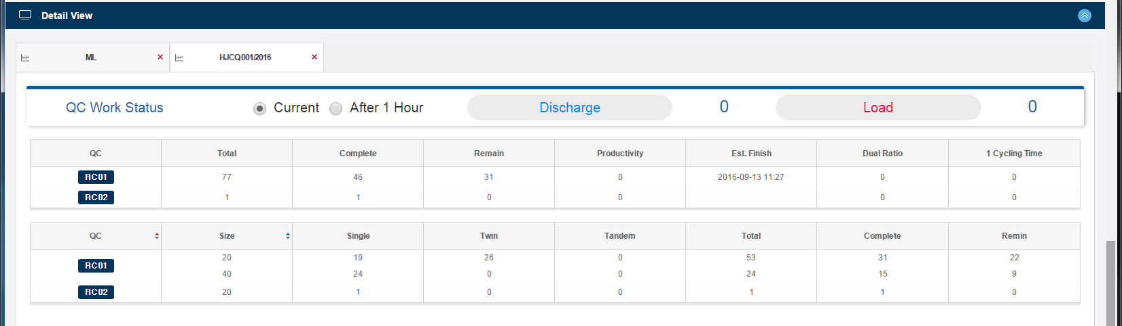
[Detail GC List Screen Layout]

Classification | Description
Discharge / Load | - Current/After 1 Hour : Input options (Current / 1 Hour Future)  - Discharge : Display the QC completed quantity for discharge work for specific vessel voyage.  - Load : Display the QC completed quantity for load work for specific vessel voyage.
QC | - Total : Display the total volume for assigning specific QC ID(Unit : Box).  - Complete : Display the completed volume for assigning specific QC ID(Unit : Box).  - Remain : Display the remain volume for assigning specific QC ID(Unit : Box).  - Productivity : Display the productivity for specific QC ID.  - Est. Finish : Display the estimated work finish time for specific QC ID.  - Dual Ratio : Display the dual cycle operation of work completion for specific QC ID.  - 1 Cycling Time : Display the completed box quantity ratio for latest 1 hour for specific QC ID.  : Completed Box Quantity / Work Time(Latest 1 Hour - Delay Time)
QC + Size | - Single : Display the single operation volume for specific QC ID and Size(Unit : Box).  - Twin : Display the twin operation volume for specific QC ID and Size(Unit : Box).  - Tandem : Display the tandem operation volume for specific QC ID and Size(Unit : Box).  - Total : Display the total volume for specific QC ID and Size(Unit : Box).  - Complete : Display the completed volume for specific QC ID and Size(Unit : Box).  - Remain : Display the remain volume for specific QC ID and Size(Unit : Box).
[Detail GC List Screen Layout Description]

Total Break Time
In this view, you can see about the total break time for all quay crane for latest 2 hours(Unit : Minute).

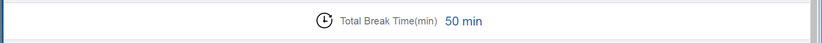
[Total Break Time Screen Layout]

QC Work Stop
In this view, you can see about the all quay crane work stop list for latest 2 hours.
It displays the detail quay crane work stop list.

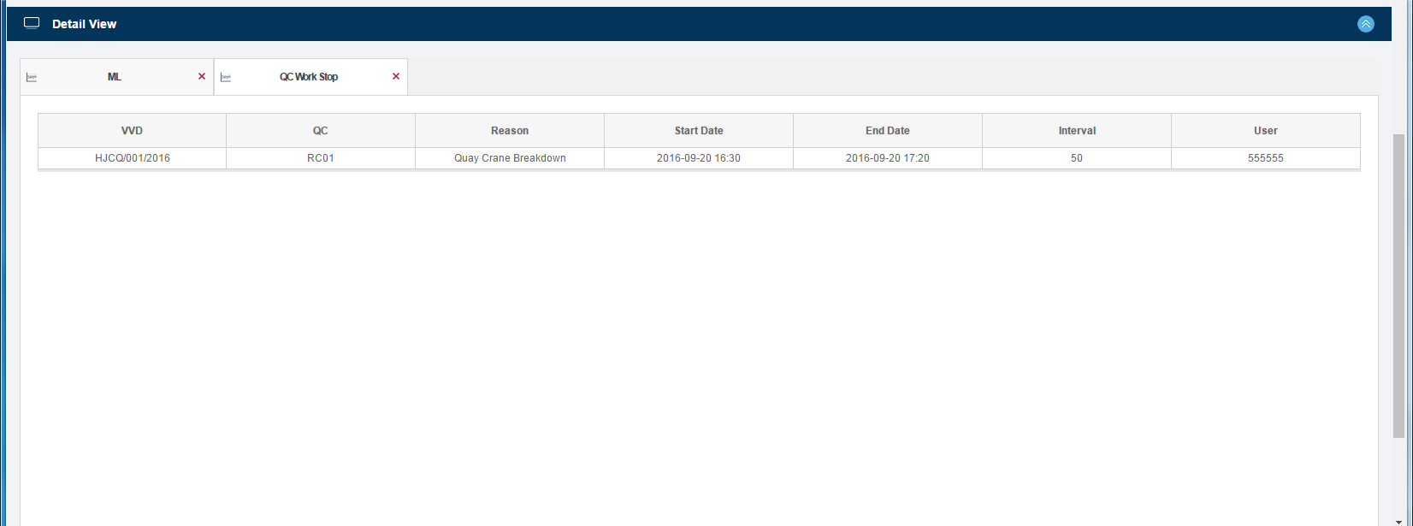
[QC Work Stop Screen Layout]

Classification | Description
Fields | - VVD : Display the target vessel / voyage for break time.  - QC : Display the target QC id for break time.  - Reason : Display the reason description for break time .  - Start Date : Display the start date/time for break time.  - End Date : Display the end date/time for break time.  - Interval : Display the interval time for break time.  - User : Display the input user data for break time.
[QC Work Stop Screen Layout Description]

Pool Status
In this view, you can see about the current pool code status.

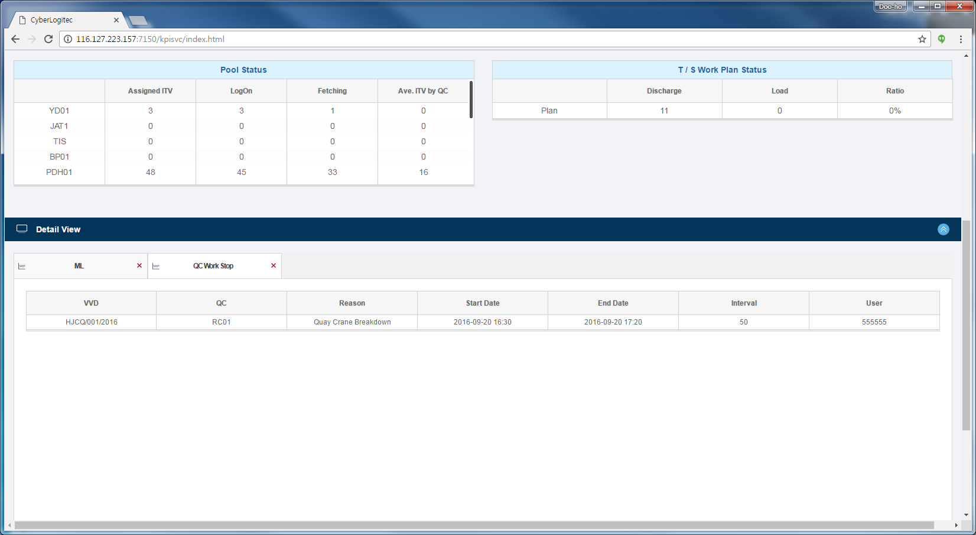
[Pool Status Screen Layout]

Classification | Description
Fields | - Assigned ITV : Display the assigned ITV machine quantity by specific pool assignment.  - LogOn : Display the logged on ITV machine quantity by specific pool code.  - Fetching : Display the fetching ITV machine quantity by specific pool code.  - Ave. ITV by QC : Display the start date/time for break time.
[Pool Status Screen Layout Description]

T/S Work Plan Status
In this view, you can see about the Work Plan Status for TS local class.
T/S work plan status is checking the gap for twin operation's plan and actual status for TS local class.

[T/S Work Plan Status Screen Layout]

Classification | Description
Fields | - Discharge : Display the discharge work volume for TS local class container.  - Lood : Display the load work volume for TS local class container.  - Ratio : Display the discharge/load work ratio for TS local class container..
[T/S Work Plan Status Screen Layout Description]

Yard
In this view, you can see about the yard operation work status summary and detail information.

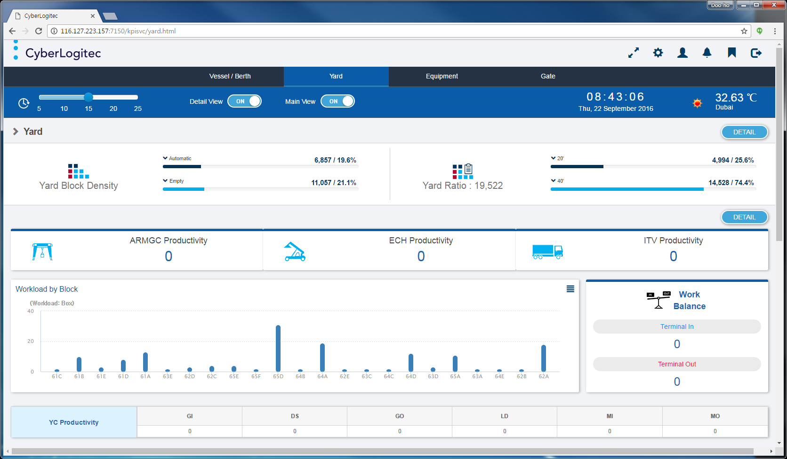
[Yard Main Screen Layout]

Yard Block Density
In this view, you can see about the yard container stacking status(Stacking TEU / Ratio ) by Automatic and Empty Block .

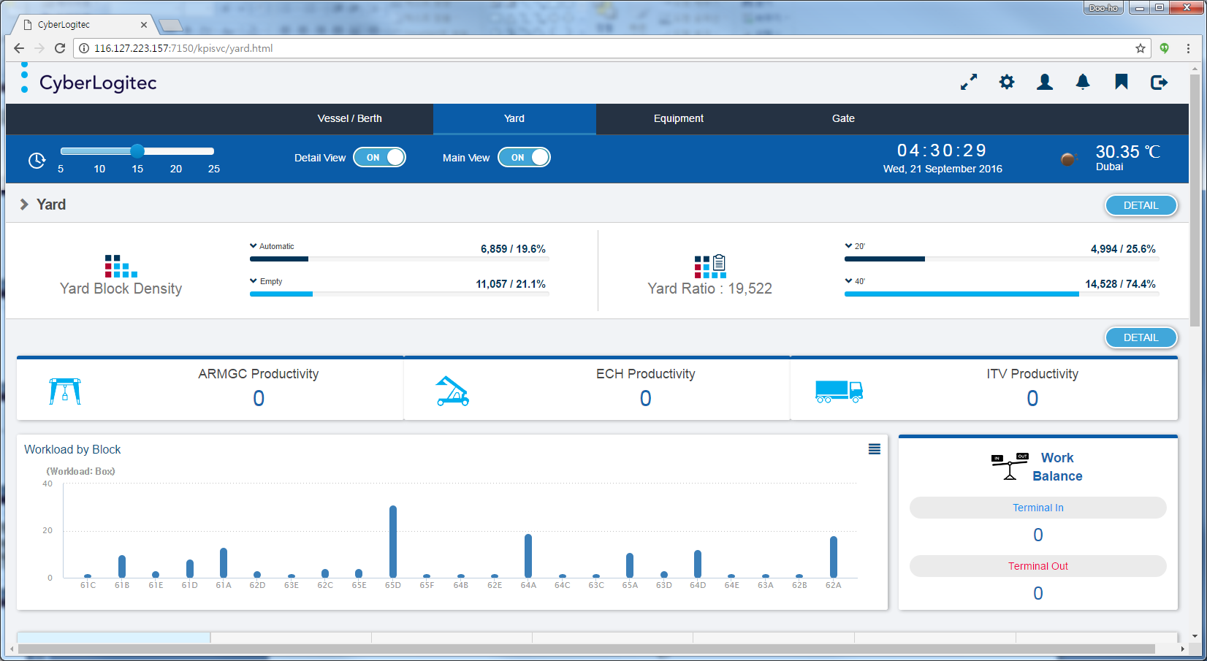[Yard Block Density Screen Layout]

Classification | Description
Fields | - Automatic : Display the yard container stacking status for Automatic blocks.  : Stacking TEU / Ratio(= Stacking TEU / Total capacity)  - Empty : Display the yard container stacking status for Empty blocks.  : Stacking TEU / Ratio(= Stacking TEU / Total capacity)
[Yard Block Density Screen Layout Description]

Yard Ratio
In this view, you can see about the yard container stacking status(Stacking TEU / Ratio ) by container size.

[Yard Ratio Screen Layout]

Classification | Description
Fields | - Yard Ratio : Display the current total yard container stacking status(Unit : TEU).  - 20' : Display the yard container stacking status for 20' container.  : Stacking TEU / Ratio(= 20' Stacking TEU / Total stacking TEU)  - 40' : Display the yard container stacking status for 40' container.  : Stacking TEU / Ratio(= 40' Stacking TEU / Total stacking TEU)
[Yard Ratio Screen Layout Description]

ARMGC/ECH/ITV Productivity
In this view, you can see about the yard machine(ARMGC/ECH/ITV) productivity for latest 1 hour.

[ARMGC/ECH/ITV Productivity Screen Layout]

Classification | Description
Fields | - ARMGC Productivity : Display the ARMGC machine productivity for latest 1 hour.  - ECH Productivity : Display the ECH machine productivity for latest 1 hour.  - ITV Productivity : Display the ITV machine productivity for latest 1 hour.
[ARMGC/ECH/ITV Productivity Screen Layout Description]

Workload by Block
In this view, you can see about the current remain workload by each yard block.

[Workload by Block Screen Layout]

Classification | Description
Fields | - (Workload : Box) : Display the yard workload quantity for specific yard block.  - Yard Block Code : Display the yard blocks for existing workload.
[Workload by Block Screen Layout Description]

Work Balance
In this view, you can see about the Terminal In(Discharge or Gate In Job) / Out(Load or Gate Out Job) job completed quantity for latest 1 hour.

[Work Balance Screen Layout]

Classification | Description
Fields | - Terminal In : Display the current terminal in job completed quantity for latest 1 hour.  - Terminal Out : Display the current terminal out job completed quantity for latest 1 hour.
[Work Balance Screen Layout Description]

YC Productivity
In this view, you can see about the yard machine productivity of each job type for latest 1 hour.
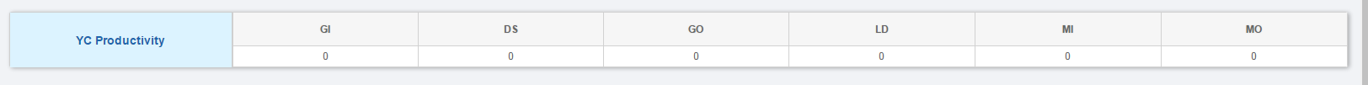
[YC Productivity Screen Layout]

Classification | Description
Fields | - GI : Display the yard machine productivity of Gate In Job for latest 1 hour.  - DS : Display the yard machine productivity of Discharge Job for latest 1 hour.  - GO : Display the yard machine productivity of Gate Out Job for latest 1 hour.  - LD : Display the yard machine productivity of Load Job for latest 1 hour.  - MI : Display the yard machine productivity of Move In Job for latest 1 hour.  - MO : Display the yard machine productivity of Move Out Job for latest 1 hour.
[YC Productivity Screen Layout Description]

Yard Stacking Status
In this view, you can see about the yard container stacking volume / ratio of class type(MT/IMP/EXP/TS/Total) by each yard block .
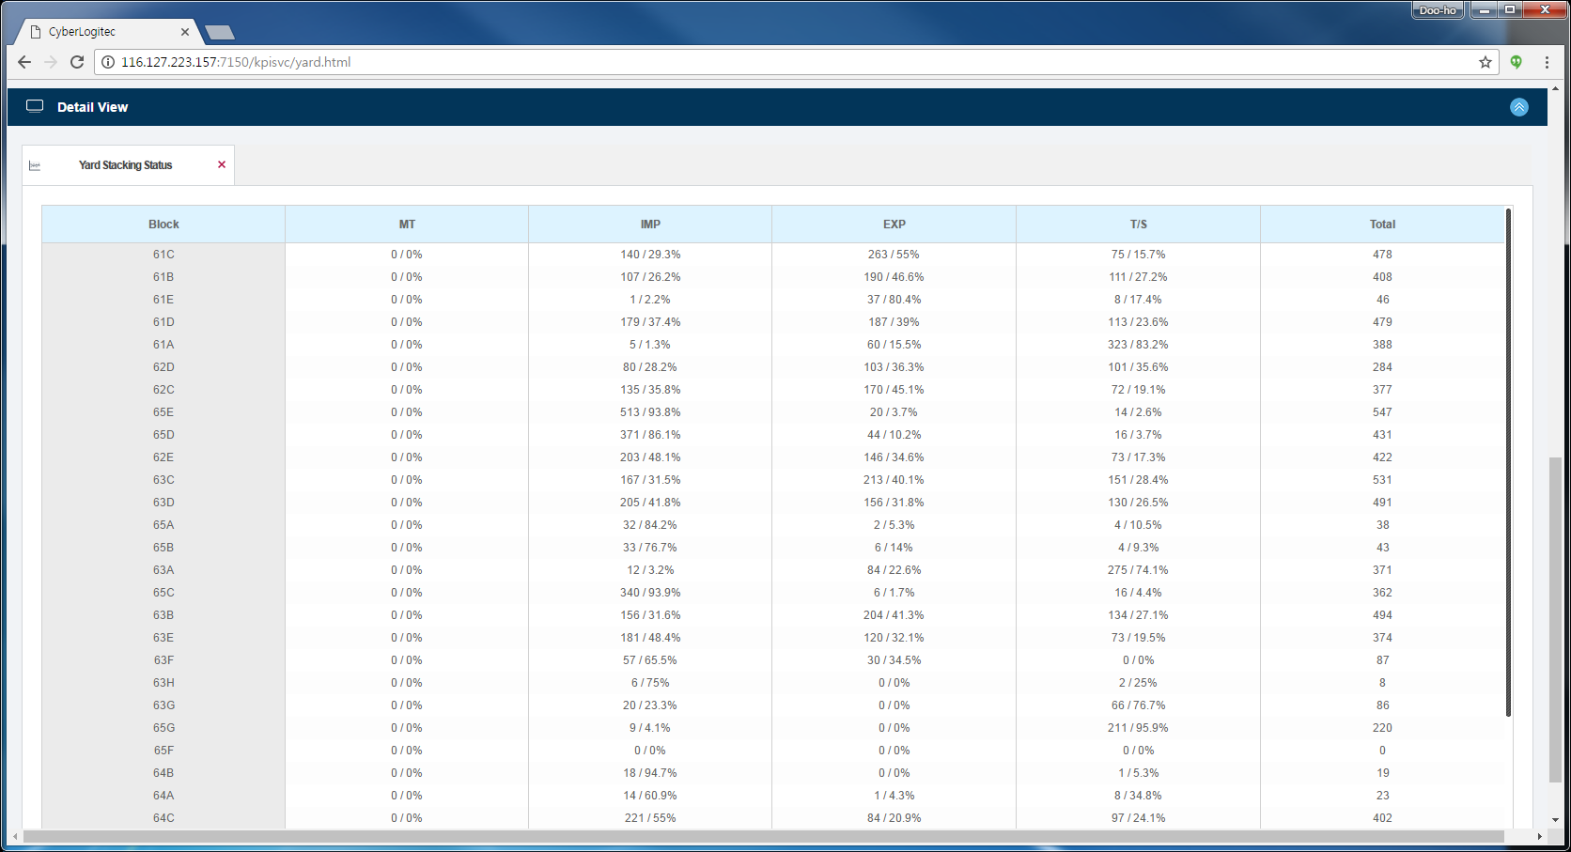
[Yard Stacking Status Screen Layout]

Classification | Description
Fields | - Block : Display the current stacking yard block code.  - MT : Display the current stacking empty container(Stacking TEU / Ratio) for specific yard block.  : Stacking TEU / Ratio(= stack TEU of specific block / Total stack TEU of specific block)  - IMP : Display the current stacking full and import class container(Stacking TEU / Ratio)  for specific yard block.  : Stacking TEU / Ratio(= stack TEU of specific block / Total stack TEU of specific block)  - EXP : Display the current stacking full and export class container(Stacking TEU / Ratio)  for specific yard block.  : Stacking TEU / Ratio(= stack TEU of specific block / Total stack TEU of specific block)  - T/S : Display the current stacking full and (T/S Local, T/S Import and T/S Export) class  container(Stacking TEU / Ratio) for specific yard block.  : Stacking TEU / Ratio(= stack TEU of specific block / Total stack TEU of specific block)  - Total : Display the current total stacking container(Stacking TEU) for specific yard block.
[Yard Stacking Status Screen Layout Description]

Block Work Status
In this view, you can see about the reefer work status, block work status and block traffic status.
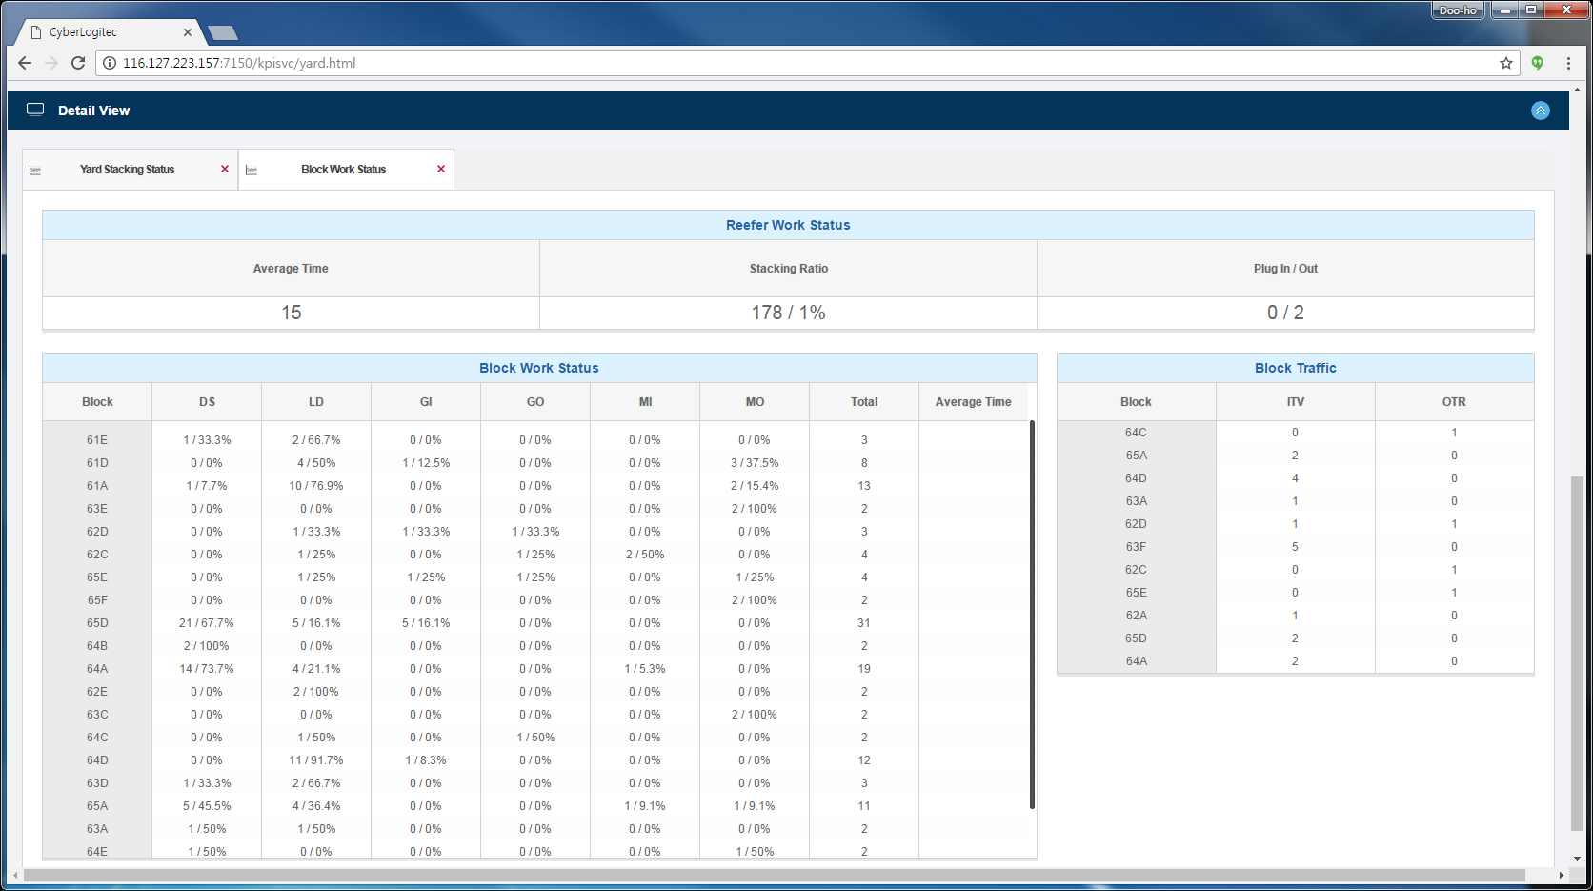
[Block Work Status Screen Layout]

Reefer Work Status
In this view, you can see about the average reefer work time, stacking TEU and Ratio of reefer block and plug in/out job list quantity of over waiting for user setup waiting time.

[Reefer Work Status Screen Layout]

Classification | Description
Fields | - Average Time : Display the average reefer work time.  : Reefer work time = Reefer job completed time - Reefer job occured event time  : Target data is during latest 1 hour.  - Stacking Ratio : Display the current stacking reefer container(Stacking TEU / Ratio)  for reefer block.  : Ratio(= stack TEU of reefer block / Total stack TEU of reefer block)  - Plug In/Out : Display the waiting plug in/out job quantity of over waiting for user setup  waiting time.  : Input the user setup waiting time on System KPI Setup module.
[Reefer Work Status Screen Layout Description]

Block Work Status
In this view, you can see about the current job type workload quantity / ratio and average working time for latest 1 hour by each yard block.

[Block Work Status Screen Layout]

Classification | Description
Fields | - Block : Display the existing yard workload yard block code.  - DS : Display the current discharge workload quantity / ratio for specific yard block.  : Discharge workload(Box) / Ratio(= Discharge workload / Total workload)  - LD : Display the current load workload quantity / ratio for specific yard block.  : Load workload(Box) / Ratio(= Load workload / Total workload)  - GI : Display the current gate-in workload quantity / ratio for specific yard block.  : Gate-In workload(Box) / Ratio(= Gate-In workload / Total workload)  - GO : Display the current gate-out workload quantity / ratio for specific yard block.  : Gate-Out workload(Box) / Ratio(= Gate-Out workload / Total workload)  - MI : Display the current movement-in workload quantity / ratio for specific yard block.  : Movement-In workload(Box) / Ratio(=Movement-In workload / Total workload)  - MO : Display the current movement-out workload quantity / ratio for specific yard block.  : Movement-Out workload(Box) / Ratio(=Movement-Out workload / Total workload)  - Total : Display the current all yard job workload quantity for specific yard block.  : Workload includes Processing, Active, Inactive and Bypass job status.  - Average Time : Display the average worktime for latest 1 hour on specific yard block.  : Work time = Job completed time - Job processing time
[Block Work Status Screen Layout Description]

Block Traffic Work Status
In this view, you can see about the current ITV/OTR waiting volume by over waiting for user setup waiting time on each yard block.

[Block Traffic Work Status Screen Layout]

Classification | Description
Fields | - Block : Display the yard block code of existing ITV/OTR over waiting time.  - ITV : Display the current existing ITV volume by over waiting for user setup waiting time  for specific yard block.  - OTR : Display the current existing OTR volume by over waiting for user setup waiting time  for specific yard block.
[Block Traffic Work Status Screen Layout Description]

Plug In/Out List
In this view, you can see about the waiting plug in/out list by clicking the Plug In/Out item.
[Click the Plug In/Out item]

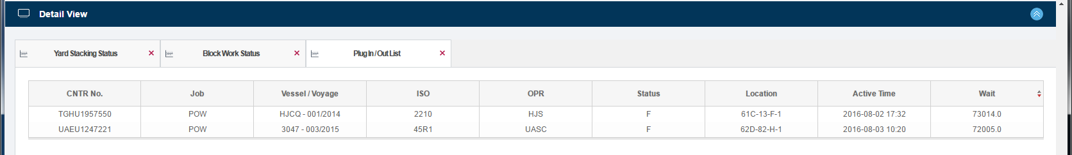
[Plug In/Out List Screen Layout]

Classification | Description
Fields | - CNTR No. : Display the container number for target reefer container.  - Job : Display the reefer job type for target reefer container.  - Vessel / Voyage : Display the vessel / voyage information for target reefer container.  - ISO : Display the ISO code for target reefer container.  - OPR : Display the operator code for target reefer container.  - Status : Display the container status for target reefer container.  - Location : Display the inventory yard position for target reefer container.  - Active Time : Display the job occuered time of reefer job for target reefer container.  - Wait : Display the reefer job waiting time for target reefer container.
[Plug In/Out List Screen Layout Description]

Block Traffic List
In this view, you can see about the waiting block traffic list by clicking the Block Traffic item.
[Click the Block Traffic item]

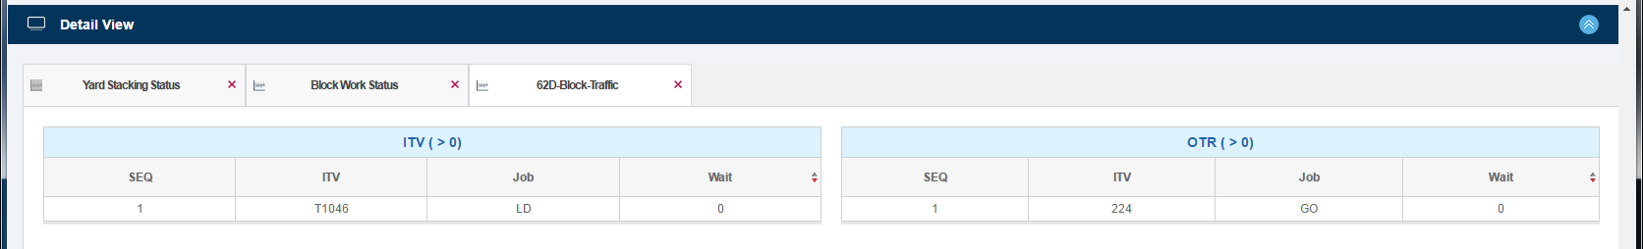
[Block Traffic List Screen Layout]

Classification | Description
ITV | - SEQ : Display the sorting order sequence for waitting time.  - ITV : Display the ITV Number for specific ITV.  - Job: Display the ITV Job Type for specific ITV.  - Wait : Display the ITV waiting time for specific ITV.
OTR | - SEQ : Display the sorting order sequence for waitting time.  - OTR : Display the OTR Number for specific OTR.  - Job: Display the OTR Job Type for specific OTR.  - Wait : Display the OTR waiting time for specific OTR.
[Block Traffic List Screen Layout Description]

Equipment
In this view, you can see about the all machine type(QC/ARMGC/ECH/ITV) work status summary and detail information.

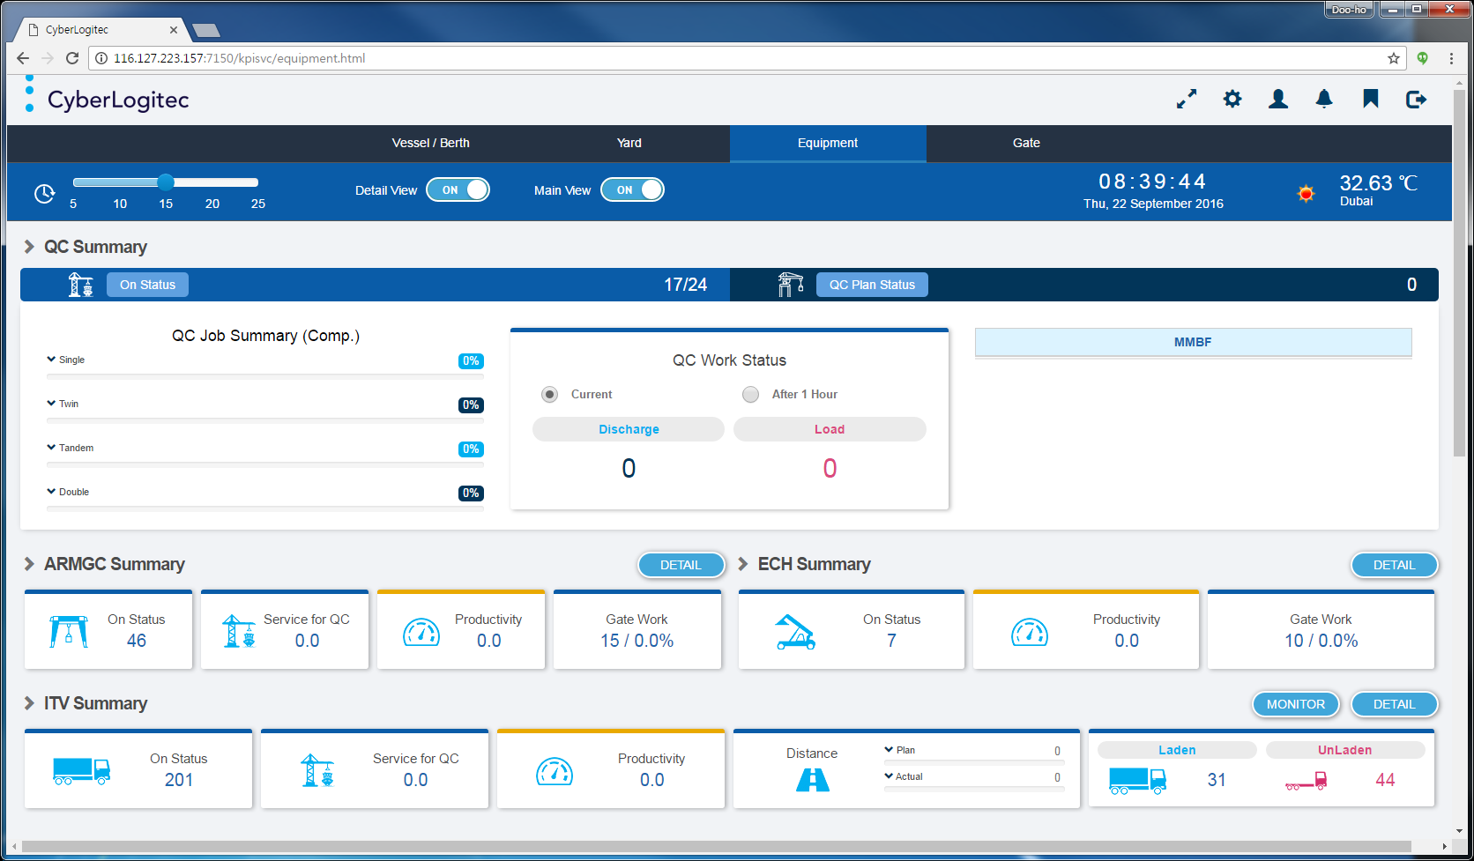
[Equipment Main Screen Layout]

QC Summary
In this view, you can see about the QC machine work status summary .

[QC Summary Screen Layout]

Classification | Description
Fields | - On Status : Display the current working QC machine / total QC machine quantity.  - QC Plan Status : Display the all planned QC machine quantity during next 4 hours.  - QC Job Summary(Comp.) : Display the QC completed work ratio for Single / Twin / Tandem /  Double Operation during 3 hours.  - MMBF : Display the average QC moves for breakdown by machine manufacture.  - QC Work Status : Display the all QC work(Discharge/Load) final status for current or 1 hour  future option.
[QC Summary Screen Layout Description]

ARMGC Summary
In this view, you can see about the ARMGC machine work status summary .

[ARMGC Summary Screen Layout]

Classification | Description
Fields | - On Status : Display the current working(log-on) ARMGC machine quantity.  - Service for QC : Display the average service QC machine quantity for each ARMGC.  - Productivity : Display the current ARMGC productivity for latest 1 hour.  - Gate Work : Display the gate workload quantity and gate work level(%) for ARMGC block.  : Gate work level(%) = Gate workload / (ARMGC Productivity Ⅹ On Status) Ⅹ 100
[ARMGC Summary Screen Layout Description]

ARMGC Work Status
In this view, you can see about the detail work status of ARMGC machine by clicking the "DETAIL" button on ARMGC Summary.

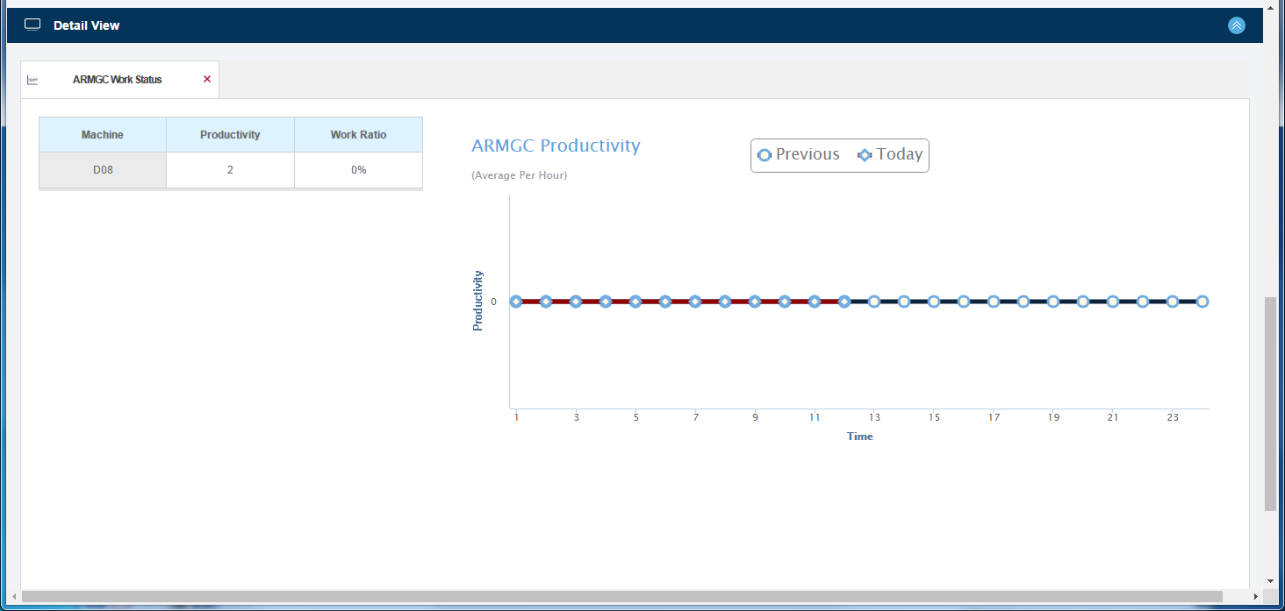
[ARMGC Work Status Screen Layout]

Classification | Description
Fields | - Machine : Display the current working ARMGC ID Number.  - Productivity : Display the each ARMGC machine productivity for latest 1 hour.  - Work Ratio : Display the real working time ratio of ARMGC machine for latest 1 hour.  : Work Ratio(%) = (Job comp. time - Job process time) / 60 Ⅹ 100  - Line Graph(Today) : Display the current(today) hourly productivity line graph for ARMGC.  - Line Graph(Previous) : Display the 7 days ago date hourly productivity line graph for ARMGC.  : Target date is a week before(Same weekday).
[ARMGC Work Status Screen Layout Description]

ECH Summary
In this view, you can see about the ECH machine work status summary .

[ECH Summary Screen Layout]

Classification | Description
Fields | - On Status : Display the current working(log-on) ECH machine quantity.  - Productivity : Display the current ECH productivity for latest 1 hour.  - Gate Work : Display the gate workload quantity and gate work level(%) for ECH block.  : Gate work level(%) = Gate workload / (ECH Productivity Ⅹ On Status) Ⅹ 100
[ECH Summary Screen Layout Description]

ECH Work Status
In this view, you can see about the detail work status of ECH machine by clicking the "DETAIL" button on ECH Summary.

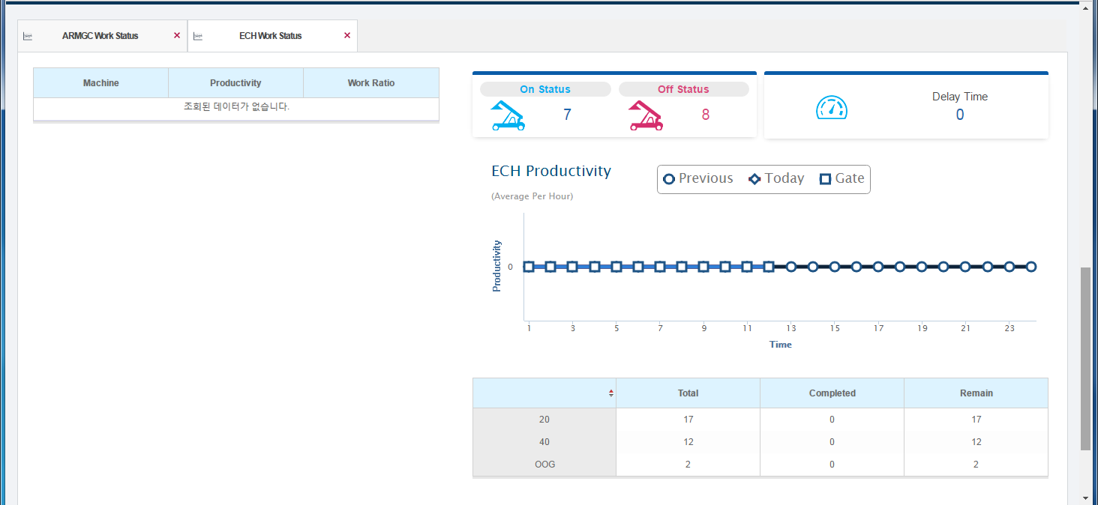
[ECH Work Status Screen Layout]

Classification | Description
Fields | - Machine : Display the current working ECH ID Number.  - Productivity : Display the each ECH machine productivity for latest 1 hour.  - Work Ratio : Display the real working time ratio of ECH machine for latest 1 hour.  : Work Ratio(%) = (Job comp. time - Job process time) / 60 Ⅹ 100  - On Status : Display the current working(logged-on) ECH machine quantity.  - Off Status : Display the current logged-out ECH machine quantity.  - Delay Time : Display the total break time for ECH machine.  - Line Graph(Today) : Display the current(today) hourly productivity line graph for ECH.  - Line Graph(Gate) : Display the current hourly productivity for only gate job(Gate In/Gate Out)  line graph for ECH machine.  - Line Graph(Previous) : Display the 7 days ago date hourly productivity line graph for ECH.  : Target date is a week before(Same weekday).  - Total : Display the total volume of 20'/40'/OOG size for completing ECH machine(Unit : Box).  - Completed : Display the completed volume of 20'/40'/OOG size for completing ECH machine.  - Remain : Display the remain volume of 20'/40'/OOG size for completing ECH machine.
[ECH Work Status Screen Layout Description]

ITV Summary
In this view, you can see about the ITV machine work status summary .

[ITV Summary Screen Layout]

Classification | Description
Fields | - On Status : Display the current working(log-on) ITV machine quantity.  - Service for QC : Display the average service QC machine quantity for each ITV.  - Productivity : Display the current ITV productivity for latest 1 hour.  - Laden/Unladen : Display the laden/unladen status quantity for On Status ITV.  - Plan/Actual Distance : Display the average ITV distance for Plan and Actual condition  during latest 2 hours.
[ITV Summary Screen Layout Description]

ITV Work Status
In this view, you can see about the detail work status of ITV machine by clicking the "DETAIL" button on ITV Summary.

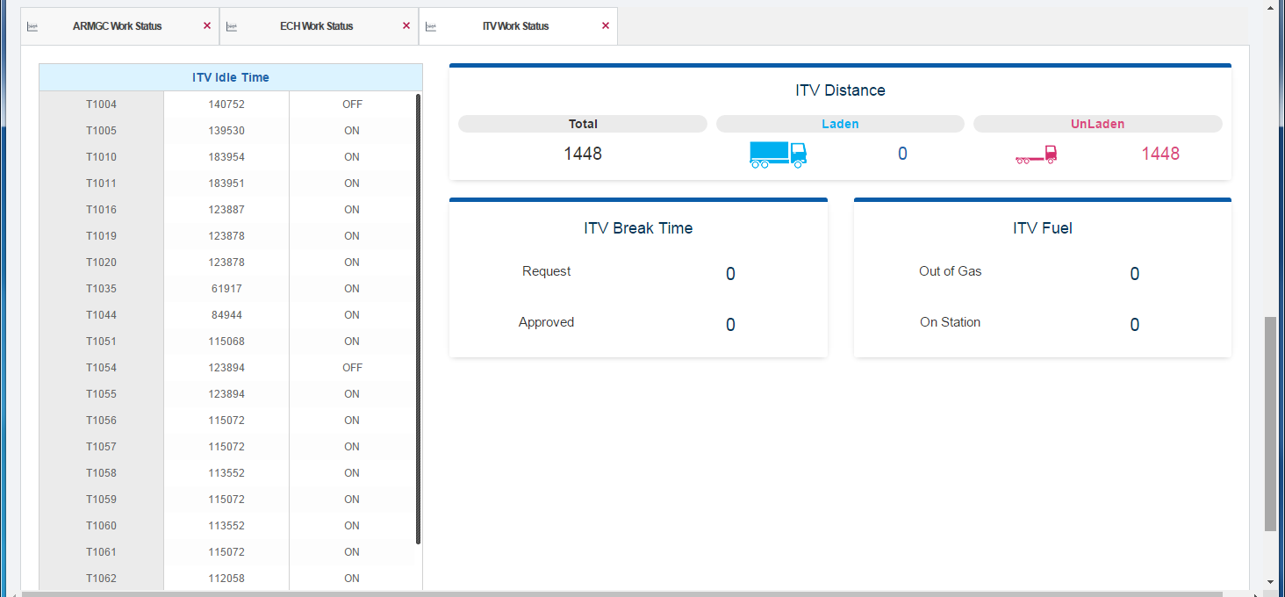
[ITV Work Status Screen Layout]

Classification | Description
Fields | - ITV Idle Time : Display the ITV machine information by over waiting for user setup  waiting time.  : Display the ITV ID/Idle Time/Log On(Off) status  - ITV Distance : Display the ITV travel distance by Total/Laden/Unladen status  during latest 1 hour.  - ITV Break Time : Display the ITV Request/Approved status quantity for ITV break time.  - ITV Fuel : Display the Out of Gas / On Station ITV status quantity.  : Out of Gas - ITV quantity with fuel volume less than 25%  : On Station - ITV quantity on Fuel Station
[ITV Work Status Screen Layout Description]

ITV Fuel List
In this view, you can see about the ITV fuel detail information for ITV fuel status.
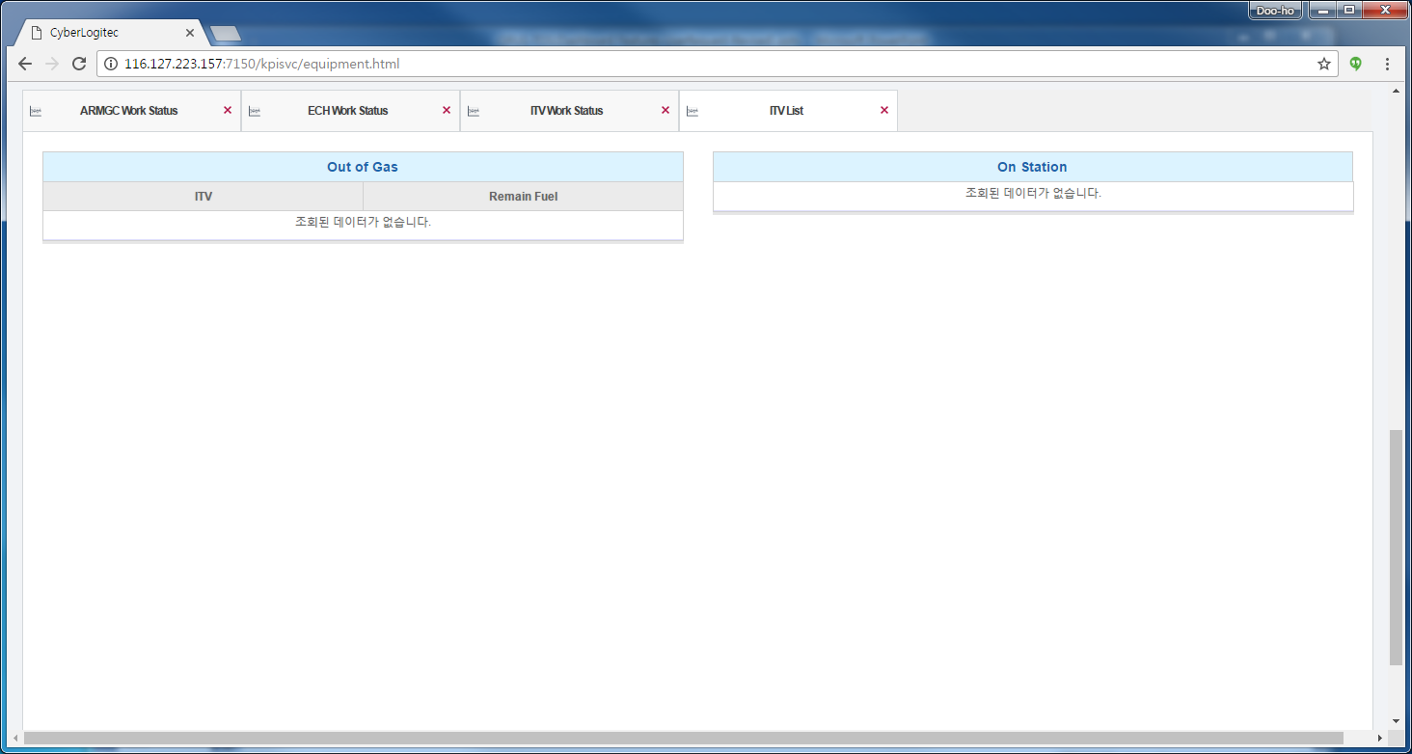
[ITV Fuel List Screen Layout]

Classification | Description
Fields | - Out of Gas : Display the ITV detail information for out of gas status.  : Display the ITV ID / Remain fuel volume data  - On Station : Display the ITV ID on gas station.
[ITV Feul List Screen Layout Description]

ITV Monitor
In this view, you can see about the current ITV job list and status for ITV monitoring.
This view is similar function with ITV Monitoring on OPUS Terminal.
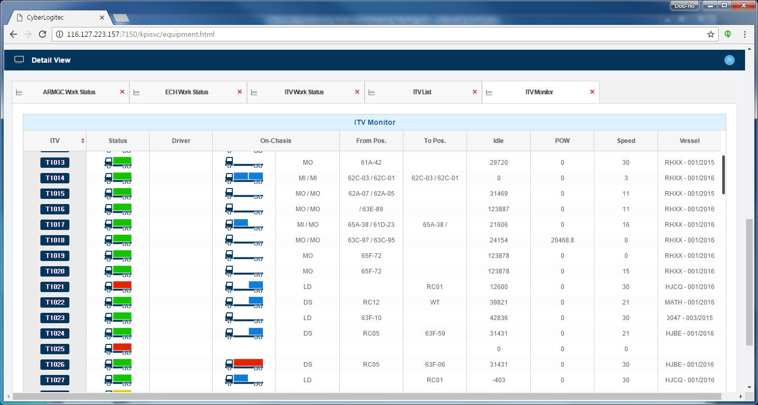
[ITV Monitor Screen Layout]

Classification | Description
Fields | - ITV : Display the target ITV Id.  - Status : Display the ITV status for target ITV Id.  : ⇒ Log-on and Job assigned  : ⇒ Log-off  : ⇒ Only Log-on  - Driver : Display the ITV driver name for target ITV Id.  - On Chassis : Display the ITV on chassis status and operation job type for target ITV Id.  : (20' Twin) / (Unladen) / (40')  : (20' Fore) / (20' Center) / (20' Back)  : DS(Discharge) / LD(Load) / MI(Movement-In) / MO(Movement-Out)  - From / To Position : Display the movement from and to yard position for target ITV Id.  - Idle : Display the ITV idle time for target ITV Id.  - POW : Display the ITV waiting time on POW Zone for target ITV Id.  - Speed : Display the current ITV speed for target ITV Id.  - Vessel / Voyage : Display the vessel / voyage information for target ITV Id.
[ITV Monitor Screen Layout Description]

Gate
In this view, you can see about the gate work status summary and detail information.

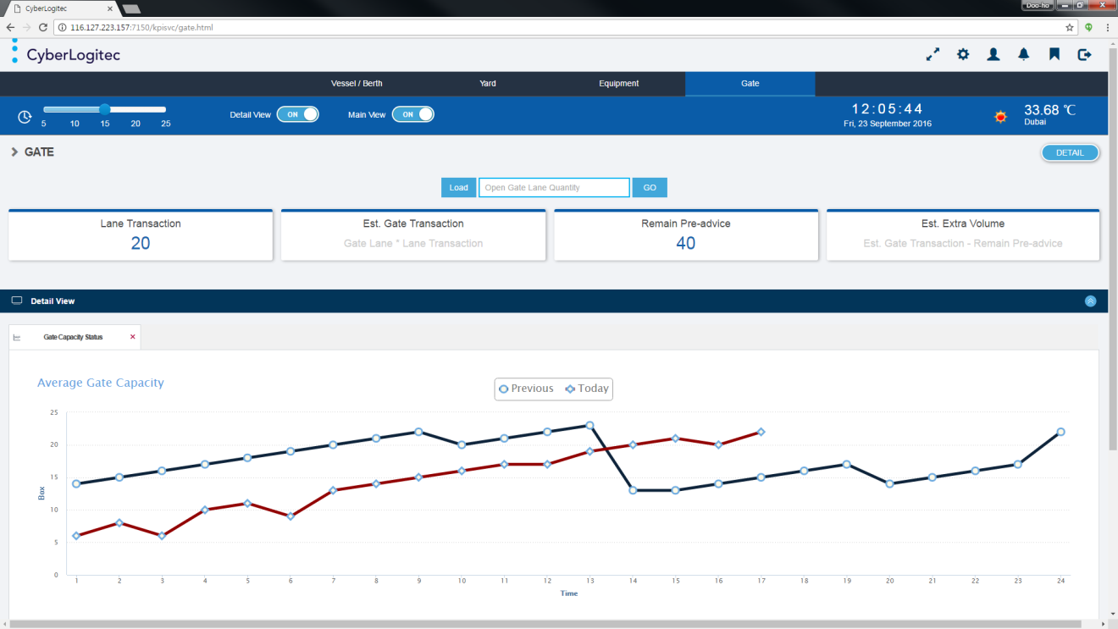
[Gate Main Screen Layout]

Gate Summary
In this view, you can see about the gate work status summary .
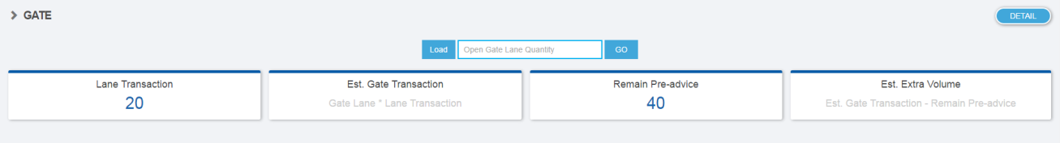
[Gate Summary Screen Layout]

Classification | Description
Commands | - Load Button : Load / Display the Lane Transaction and Remain Pre-advide data.  - Go Button : Calculate / Display the Est. Gate Transaction and Est. Extra Volume column.  : Est. Gate Transaction = Lane Transaction Ⅹ Open Gate Lane Quantity.  : Est. Extra Volume = Est. Gate Transaction - Remain Pre-advice.
Fields | - Open Gate Lane Quantity : Input the open gate lane quantity by user.  - Lane Transaction : Display the average gate transaction per hour with interface data  from PROMIS system.  - Est. Gate Transaction : Display the estimated gate transaction volume.  : Lane Transaction Ⅹ Open Gate Lane Quantity.  - Remain Pre-advice : Display the current remain gate preadvice volume with interface data  from PROMIS system.  - Est. Extra Volume : Display the estimated gate extra transaction volume.  : Est. Gate Transaction - Remain Pre-advice.
[Gate Summary Screen Layout Description]

Gate Capacity Status
In this view, you can see about the detail gate operation capacity status .
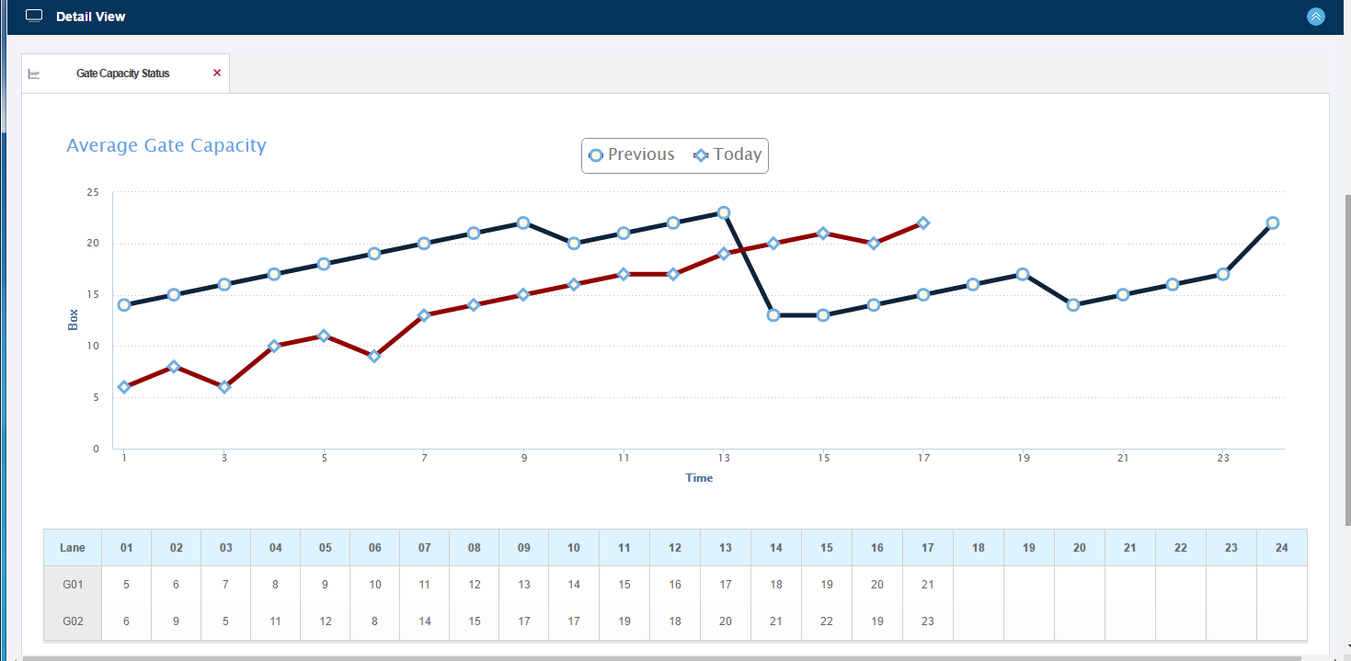
[Gate Capacity Status Screen Layout]

Classification | Description
Fields | - Line Graph(Today) : Display the current(today) hourly average gate process volume line graph  for all gate lane.  - Line Graph(Previous) : Display the 7 days ago date hourly average gate process volume line  graph for all gate lane.  : Target date is a week before(Same weekday).  - Lane : Display the current open gate lane ID with interface data from PROMIS system.  - Hourly Gate Volume : Display the current gate process volume by open gate lane ID  with interface data from PROMIS system.
[Gate Capacity Status Screen Layout Description]

Utility - System KPI Setup
In this view, you can see about the system KPI setup for monitoring the target KPI Items.

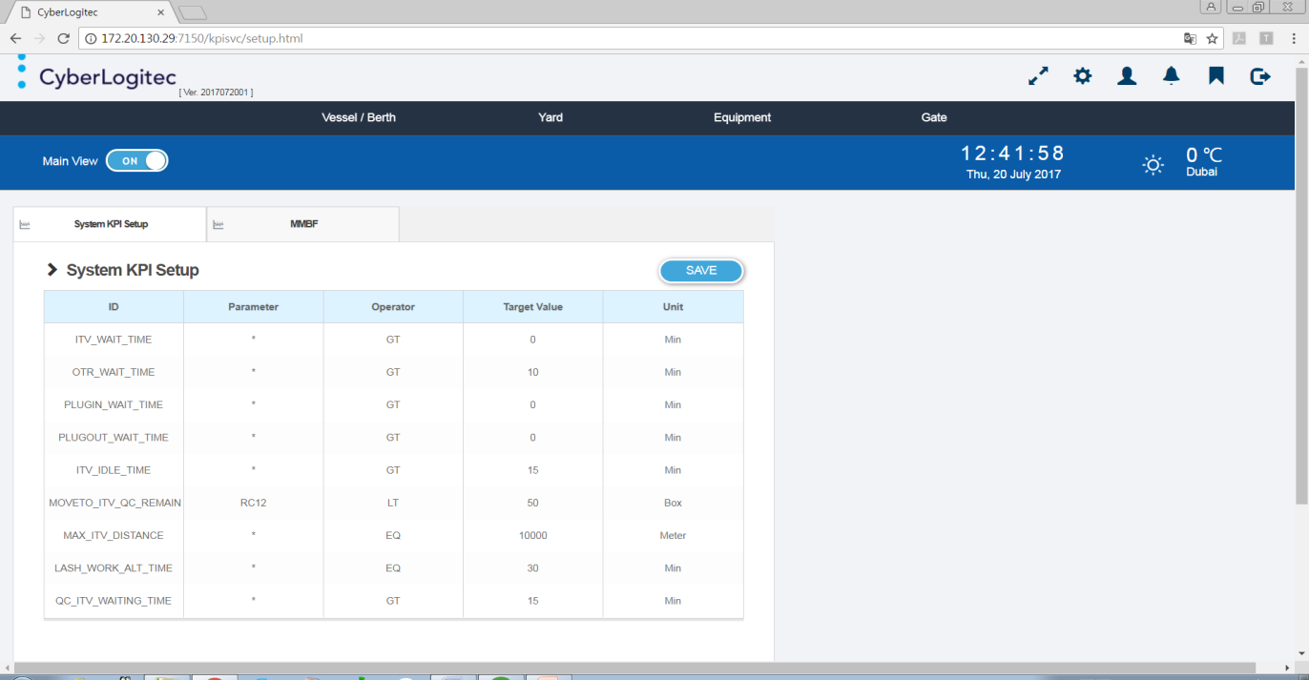
[System KPI Setup Screen Layout]

System KPI Setup
In this view, you can see and save the KPI setup value for monitoring target KPI Items.
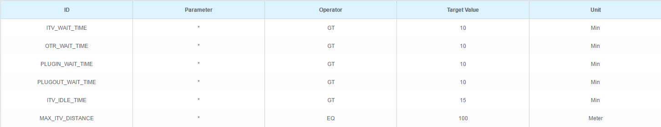
[System KPI Setup List Screen Layout]

Classification | Description
Commands | - Save Button : Save the KPI setup value for target KPI key ID.
Fields | - ID : Diaplay the target KPI key ID.  - Parameter : Diaplay the input parameter for target KPI key ID.  - Operator : Diaplay the operator for target KPI key ID.  - Target Value : Diaplay the KPI setup value for target KPI key ID.  : Save this field(KPI setup value) only by user.  - Unit : Diaplay the KPI setup value unit for target KPI key ID.

Classification | Description
Items | - ITV_WAIT_TIME : This KPI ID is the ITV setup waiting time for displaying the Block Traffic  Work Status on Yard Category.  - OTR_WAIT_TIME : This KPI ID is the OTR setup waiting time for displaying the Block Traffic  Work Status on Yard Category.  - PLUGIN_WAIT_TIME : This KPI ID is the Plug-In job setup waiting time for displaying  the Reefer Work Status on Yard Category.  - PLUGOUT_WAIT_TIME : This KPI ID is the Plug-Out job setup waiting time for displaying  the Reefer Work Status on Yard Category.  - ITV_IDLE_TIME : This KPI ID is the ITV setup waiting time for displaying  the ITV Idle Time(ITV Work Status) on Equipment Category.  - MAX_ITV_DISTANCE : This KPI ID is the ITV maximum setup distance for displaying  the ITV Pan/Actual distance(ITV Summary) on Equipment Category.  : This KPI ID is to use the maximum value for Progress Bar.
[System KPI Setup List Screen Layout Description]

MMBF
In this view, you can see and save the MMBF value for monitoring target MMBF Items.
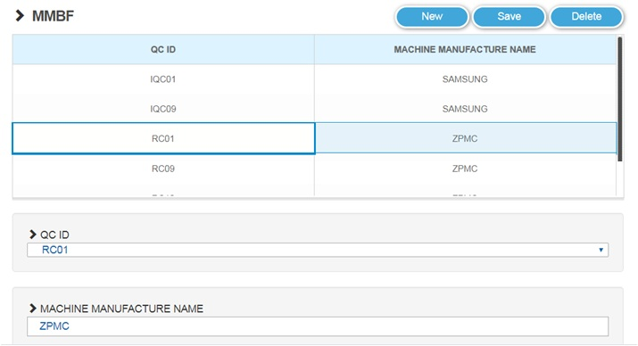
[MMBF List Screen Layout]

Classification | Description
Commands | - New Button : Save the KPI setup value for target KPI key ID.  - Save Button : Save the KPI setup value for target KPI key ID.  - Delete Button : Save the KPI setup value for target KPI key ID.
Fields | - Table / QC ID : Diaplay the QC ID.  - Table / MACHINE MANUFACTURE NAME : Diaplay the MACHINE MANUFACTURE NAME.  - Select / QC ID : Select the group QC ID.  : Save this selectbox(QC ID) only by user.  - Input / MACHINE MANUFACTURE NAME : Input the MACHINE MANUFACTURE NAME.  : Save this field(MACHINE MANUFACTURE NAME value) only by user.

Utility - User Management
In this view, you can see and save the User Management for OPUS Terminal dashboard system.

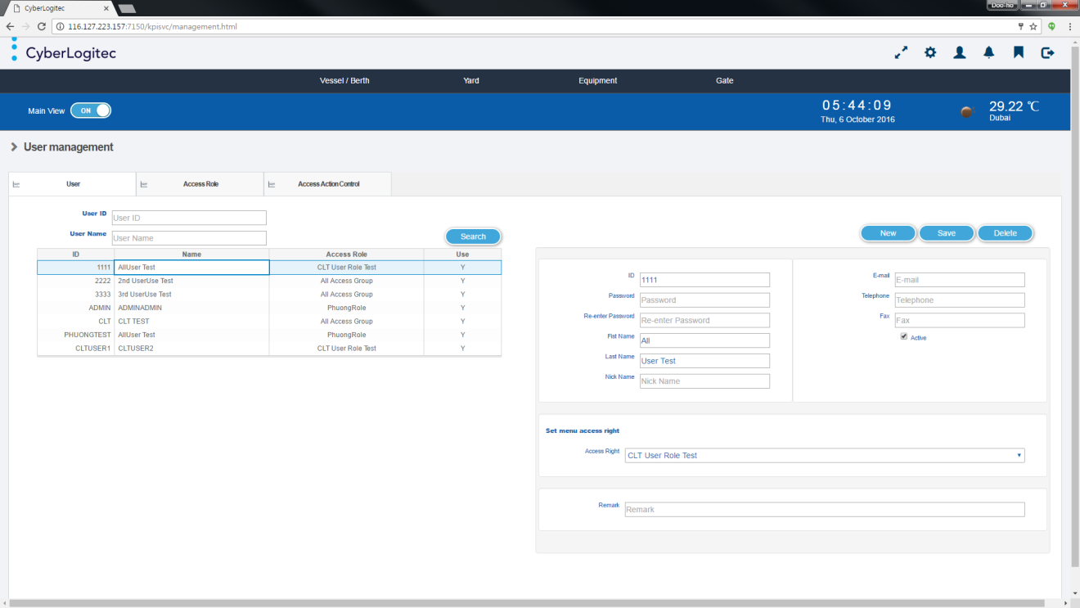
[User Management Screen Layout]

User
In this view, you can search and save the user information for OPUS Terminal Dasboard System.
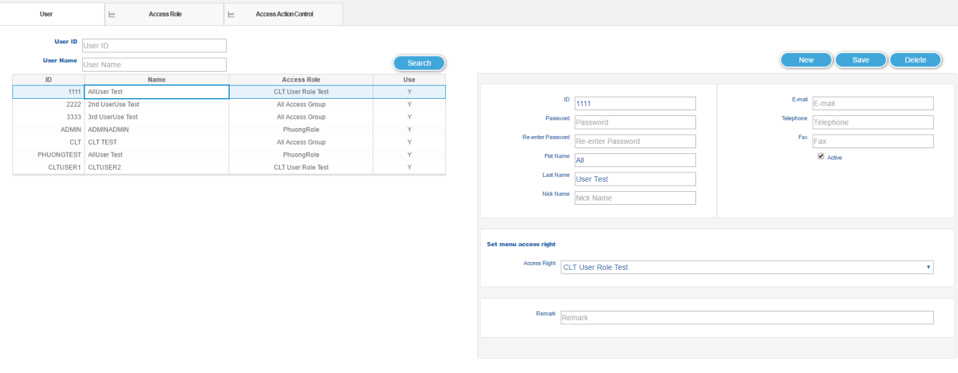
[User Screen Layout]

Classification | Description
Commands | - Search Button : Search the User List by User ID or User Name.  - New Button : Clear the all fields for saving new user information.  - Save Button : Save the user information for changing the specific user.  - Delete Button : Delete user information for specific user.

Classification | Description
Fields | - ID : Input the target User ID.  - Password : Input the password for specific User ID.  - Re-enter Password : Input the re-enter password for specific User ID.  - First Name : Input the first name for specific User ID.  - Last Name : Input the last name for specific User ID.  - Nick Name : Input the nick name for specific User ID.  - E-mail : Input the email information for specific User ID.  - Telephone : Input the telephone information for specific User ID.  - Fax : Input the fax information for specific User ID.  - Active : Input the active user confirmation for specific User ID.  - Access Right : Select the access user role group for specific User ID.  - Remark : Input the remark information for specific User ID.
[User Screen Layout Description]

Access Role
In this view, you can search and save the access group role information for OPUS Terminal Dasboard System.
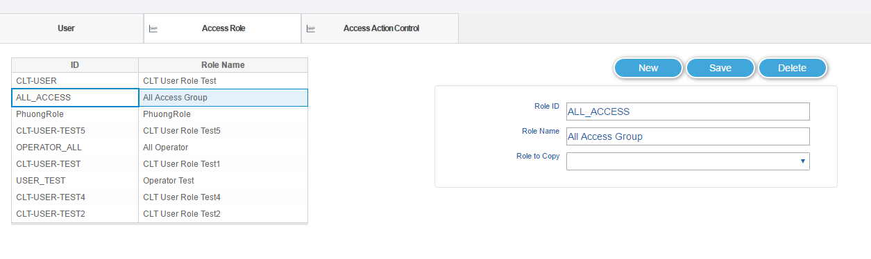
[Access Role Screen Layout]

Classification | Description
Commands | - New Button : Clear the all fields for saving new access group role information.  - Save Button : Save the access group role information.  - Delete Button : Delete the access group role.
Fields | - Role ID : Input the target access group role ID.  - Role Name : Input the target access group role Name.  - Role to Copy : Select the access group role control for copying specific access group role ID.
[Access Role Screen Layout Description]

Access Action Control
In this view, you can search and save the access action control information for specific access group role on OPUS Terminal Dasboard System.
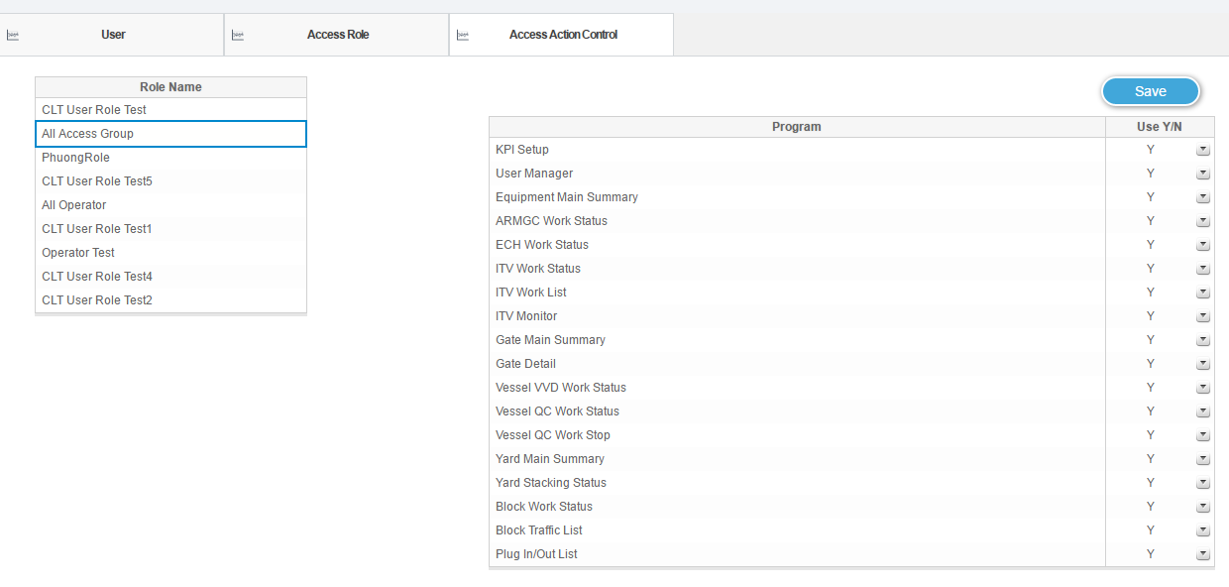
[Access Action Control Screen Layout]

Classification | Description
Commands | - Save Button : Save the access group role information.
Fields | - Role Name : Select the target access group role ID.  : Display the program access control status of target access group role ID  on right table .  - Program : Display the all program of OPUS Terminal dashboard system.  - Use Y/N : Select the program use confirmation for target access group role ID.
[Access Action Control Screen Layout Description]

